1. Create a list of all fields from the employees table.

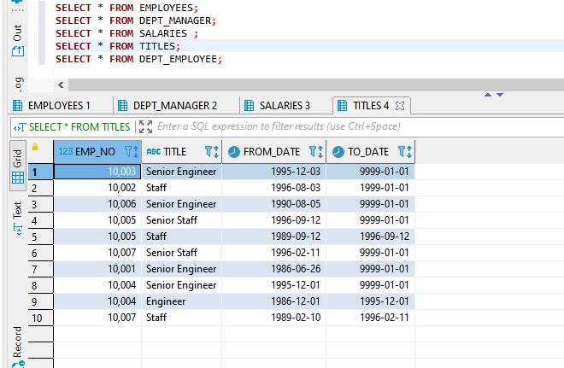

1. Retrieve a list with all female employees whose first name is Kellie.

**SELECT** * **FROM** EMPLOYEES **WHERE** FIRST_NAME = 'KELLIE' **AND** GENDER = 'F'

1. Retrieve a list with all employees whose first name is either Kellie or Aruna.

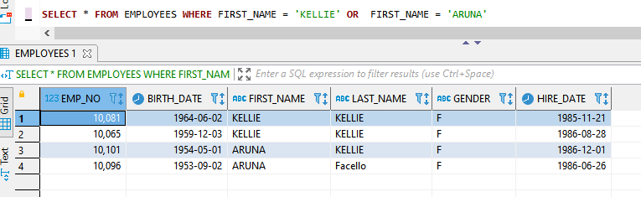

1. Create a list of all fields from employees table that are female and the first name is either Kellie OR Aruna. (be wary of order of precedence!)

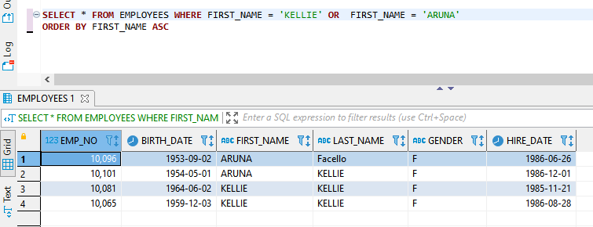

1. Use the IN operator to select all individuals from the “employees” table, whose first name is either “Denis”, or “Elvis”.

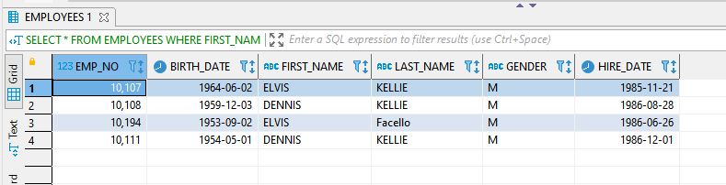

1. Extract all records from the ‘employees’ table, aside from those with employees named John, Mark, or Jacob.

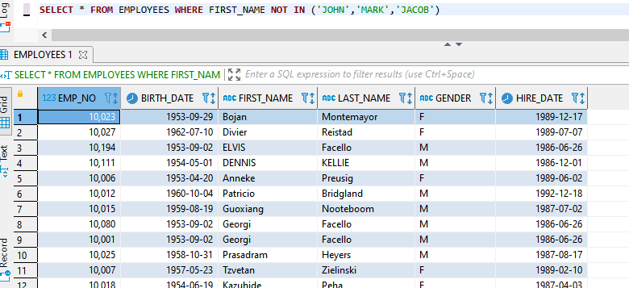

1. Select all the information from the “salaries” table regarding contracts from 66,000 to 70,000 dollars per year.

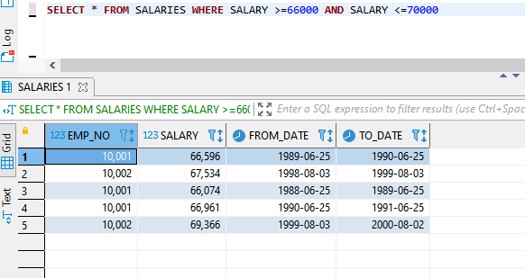

1. Retrieve a list with all individuals whose employee number is not between ‘10004’ and ‘10012’.

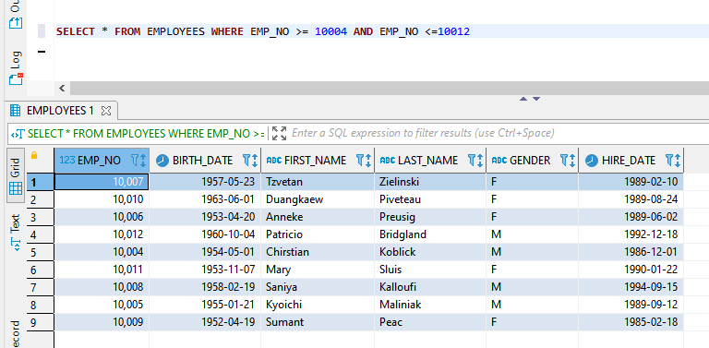

1. Using the views provided in the employees database,
   1. List all from the first view

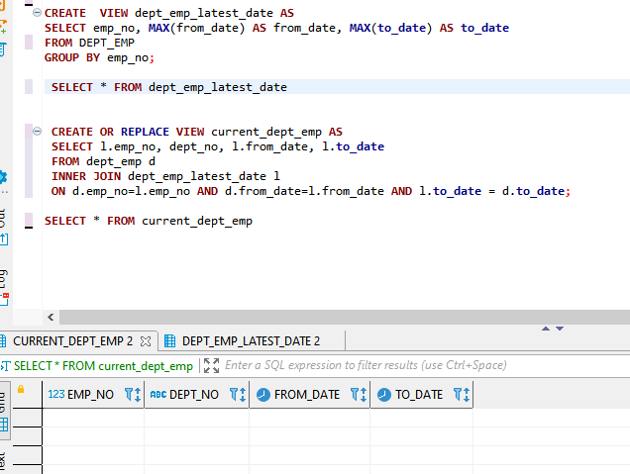

* 1. List all from the next view.

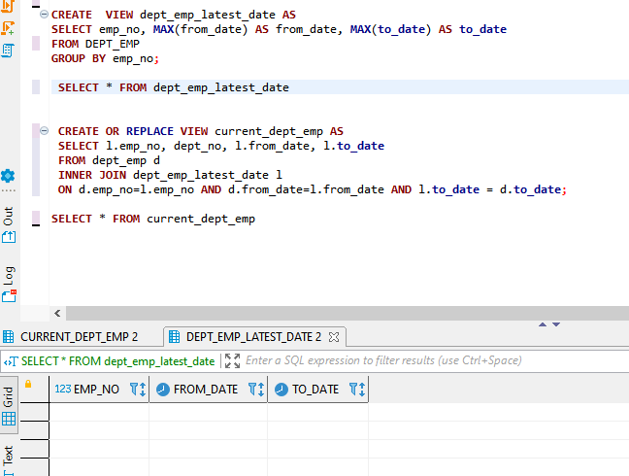

1. Create a view named new_view, it should consist of:
   1. first name (employee table)
   2. last name “ “
   3. gender “ “
   4. hire date “ “
   5. Title (from title table)
2. Retrieve all rows using the View new_view.

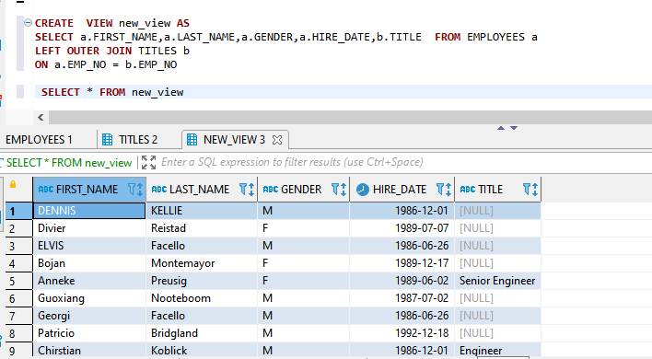

**At this point, please download the sqlscript files provided located on Bb**

1. **department_dup_create and**
2. **dept_manager_dup**

**Once saved on your PC/Mac, go to Workbench and run them (File – Run SQL Script) one at a time and IN ORDER! Refresh your schemas in Workbench, you should have two new tables. Use these new tables through the balance of the lab where applicable.**

* 1. Using the new tables (the ones with _dup at the end) extract a list containing information about all managers’ employee number, first and last name, department number, and hire date.

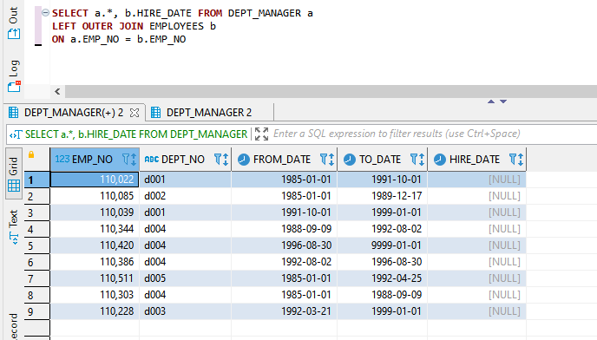

1. Join the 'employees' and the 'dept_manager_dup' tables to return a subset of all the employees whose last name is Markovitch. See if the output contains a manager with that name.

Hint: Create an output containing information corresponding to the following fields: ‘emp_no’, ‘first_name’, ‘last_name’, ‘dept_no’, ‘from_date’. Order by 'dept_no' descending, and then by 'emp_no'.

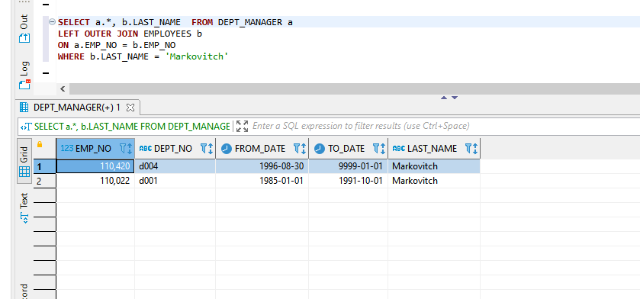

1. Select all managers’ first and last name, hire date, job title, from date, and department name. This requires joining more than two tables!

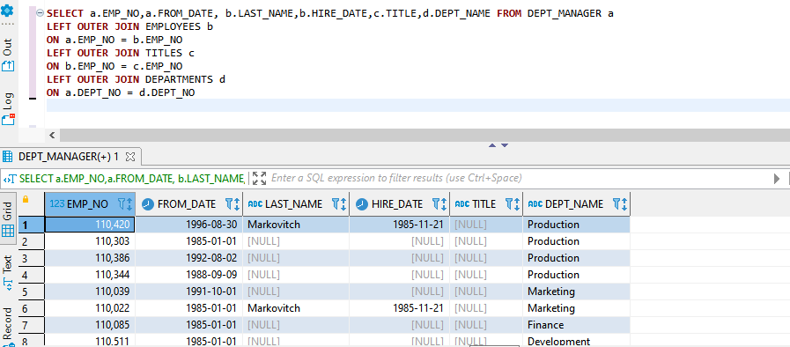

1. Now, create a TEMPORARY table called tempsales.
   1. Add a column product_name varchar(25), do not allow nulls
   2. Add a column tot_sales Integer unsigned, do not allow nulls default the value to zero.

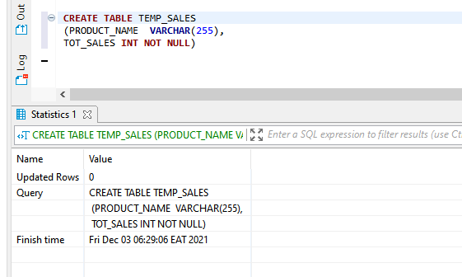

* 1. Issue a use command to Tempsales

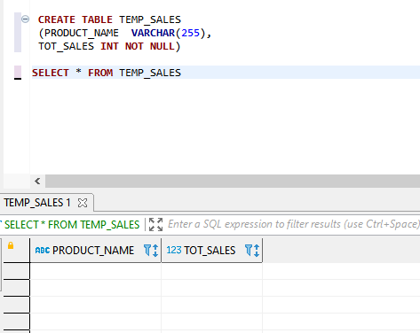

1. Insert two rows of data
   1. product_name ‘apples’ and ‘cherries’
   2. tot_sales 100 and 200

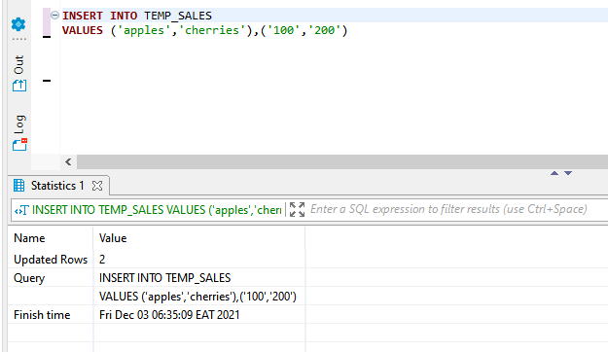

1. Select all rows all columns from tempsales.

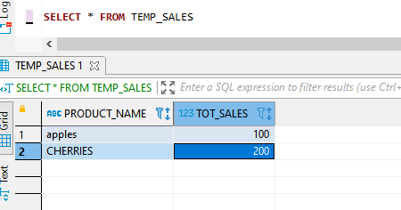

1. Finish the following SQL statements with a Case statement that extends gender of ‘F’ into Female, and ‘M’ into Male in your list.

With tempemp as (

Select emp_no, gender

CASE WHEN

   GENDER = ‘F’ THEN ‘FEMALE’

   ELSE ‘MALE’

From

employees

)

select

emp_no, gender,

     ORDER BY GENDER, EMP_NO  ASC

Please order by your extended gender label and then by emp_no.